Practical 5
Matshidiso Dibakoane - u25227506
Angela Ramaboea – u25445392
Maeryn Pillay – u25146484
TASK 4
UML:
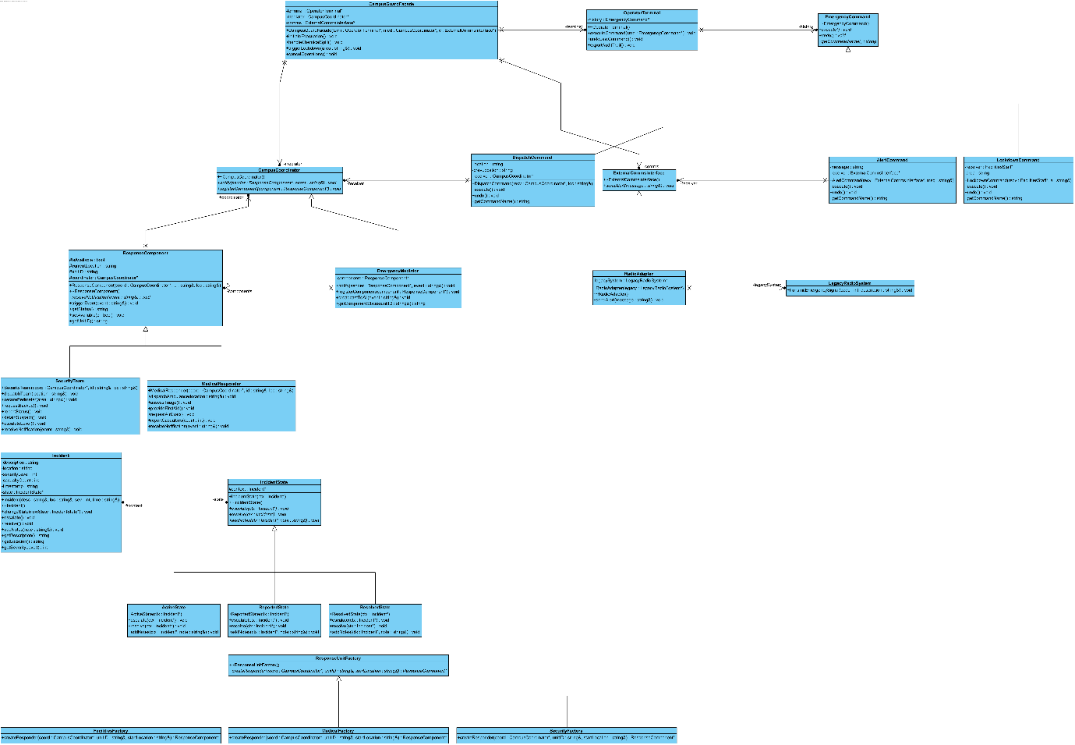

Sequence Diagrams
- Command + Mediator
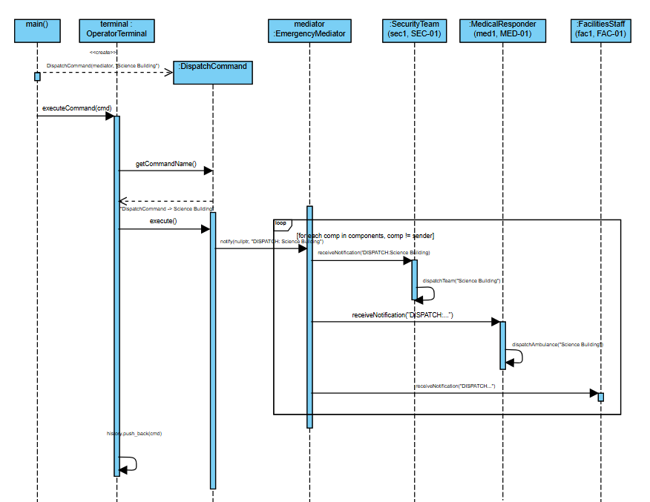
- Facade + Adapter + Mediator + Command (Chemical Spill)
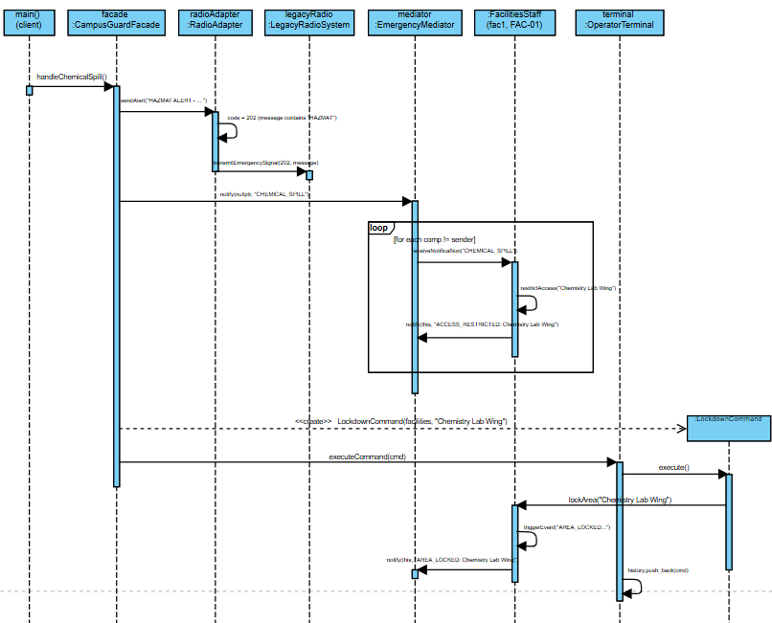

- State Diagram
- 